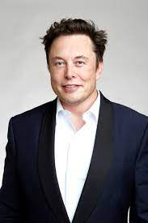
Elon musk
I am Najam Ali Abass, today I will tell you
about my favorite and ideal personality.
Elon musk is a business magnate,Industrial designer
and engineer. He is founder , CEO , CTO , and chief
designer at space-X ,early investor, CEO, and product
architect of Tesla. I adore and follow Elon the most because he is a full time geek who is consistently changing the world around him. He is versatile because he deeply attach with all the companies he belong, he is CEO ,programmer and founder at the same time and most of the people call him the real “Iron Man” because of his courage and involvement in technology. He never complain about anything rather he make the world around him better and he never give up as his may projects failed and it is impossible to achieve with current technology but he is doing hard work day and night to achieve his goal. This determination and hard work influence me and million of other people to follow him, he achieve all his dream which seems insane to ordinary people. He is an optimistic person who want to explore the universe beyond our earth and he want develop a viable colony on mars which is a long term thinking about the survival of our civilization. All these qualities make him an influential and lovable person.

